Abstract:

The following lesson plan has been built on two framework models: a) CELTA and b) the company's specific framework for a grammar & vocabulary lesson delivered to secondary school students. Among the most important features debated within this work are: 1. [CEFR] extensions and adaptabilities, 2. [MEM] & [IDM], 3. lesson’ driving questions extension, 4. [TPR/TDR] applicability & signposting, 5. differentiated [CM], 6. CEFR interaction progress, 7. term index creation, 8. positive reinforcement strategies, 9. [i]less paradigm, and 10. [d12] theorem.
We argue that an [i] individual procedure to the process of teaching-learning should be avoided and almost never be used in the context of a communicative approach. There are few instances where a teacher might practice [i], as for individual pronunciation drilling/corrections. We have integrated CEFR levels within the interaction assigned table, to distinguish between different approaches of interaction, and highlight correct schematas such as [S] - [S] - [P] - [P] = [G] - [T] {correct} where the focus is put on decreasing [TTT], and student centered alternatives. Teachers are no longer the middleman, coordinating the process of learning, but someone who makes the most out of the communicative approach, very popular in the ELT ESL curriculum.
The principle of [dif] differentiation has been used in order to grade both [CM], and lesson staging, and make them suitable for a teenagers’ class where mental health is as important as physical health. By means of a positive reinforcement *see CM Secondary slides - we have successfully achieved a great learning environment for the students and their well-being [idm:dif].
Through a new educational paradigm, called [IDM] instructional design methodologies, we have identified five driving dimensions for ELT ESL core system, and developed a methodological theorem called [d12] dodecahedron theorem based on a 3D geometrical figure *see 2D attachment schemata below CC0 1.0 - that analyzes different [dx] dimensions and [dw] driving words. We argue that in the 21st Century different sciences and their branches are interconnected and codependent. Therefore, new and emerging subjects, such as [MEM] Mechatronics of Educational Management, or [IDM] Instructional Design Methodologies could eventually answer futuristic questions related to Global Education and to the human race readiness towards the future.

Ho Chi Minh, Vietnam. May 10th 2023

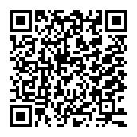
[logo]

Collaborative CELTA
[framework]

Delivered by:  Observer:  Teacher Assistant: | [T] | Date / time  of obs: | Day  Month  Year |  | Time: |  | o’clock
 | [ST]
 | [TA]
School & Class: | School’s name  class  (info directions; ex.: next to the teacher’s room) | No. of students: | Number of students  & absents (student numbers)
Lesson Title: | Example:  Week 33: Second Conditional | Example:  Resources:  Matching GAME  Lesson Folder  [CM] Secondary  Tieng Anh 9 | Copy-paste:  https://docs.google.com/presentation/d/1RbK0fJwLSWN7YNZ6CBf-cE8TF8t85U9l0LF7h_MfmL8/edit?usp=sharing  QR lesson folder:  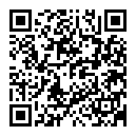  Copy-paste:  https://drive.google.com/drive/folders/1Z51ZonIY-F0cwZ_bTOqlqy4zgcn2W3kI?usp=sharing
Obs.: The given school curricula says to teach both first and second conditionals. Principle of [dif] differentiation has been applied mainly because:
- Teacher doesn’t have enough time to teach both conditionals [45 (30) minutes];
- Students don’t have enough foundation, but:
- first conditional lesson has been taught several times;
- Level of age: 50 teenagers class.

Main aim:  [Grammar] | By the end of the lesson, the students will be able to identify, talk about and understand the form, meaning, and pronunciation of the Second Conditional. | Subsidiary aims:  [Vocabulary] | By the end of the lesson, the students will have improved their ability to identify the words, their meaning, form and pronunciation from the last lesson’ vocabulary using natural intonation, tone and sentence stress.
Materials (include links to Google documents) | [analog]  Prints out: QR codes for students with the lesson slides; chalk, board, TV, microphone, laptop, presenter, CM treats, HDMI cable, chalk markers; printed CM rules, magnets;  [digital]  Google Lesson slides  Bitmoji ; Secondary (wheelofnames.com) ;  [Slides Timer]: Slides Timer - Magazinul web Chrome (google.com) ;  https://wheelofnames.com/brs-79y | Signposting  See Google Slides Lesson doc.  Index:  a) lesson title;  b) vocab;  c) date;  d) class mark;  e) matching flashcards;  f) teams  g) stars | Revision:  Vocabulary  amethyst = a me tit ?  mineral =  creature = |  |  | Unit & Week number:  Unit 10; Week 32  weather balloon =  plant =  UFO =  gemstone =  meteor =  gas =  water =
a) How does this lesson relate to previous lessons? | It builds upon knowledge learnt across the unit, reviews vocabulary within the unit, and facilitates repetition. Also, builds upon specific grammar features, such as the 1st conditional that the students have studied several times. | Classroom management system  [CM] | A CM based on differentiation has been used for this class. The differentiation was thought from two different perspectives: positive reinforcement, and group of age.  It’s important to stress that this [nr] class is a class of teenagers. There is a specific way of how to talk, what to say, or how to behave within a teenager’s environment. Therefore, different TPRs/TDRs (example: short animations, gifs, sound effects) were used in order to ensure CM success.  The CM is fully based on positive reinforcement, and a fun reward system. If, at the end of the lesson, the class succeeded to keep the 10.00 mark on the board, there will be a spinning wheel, and 1 (one) student will get a treat.  As the system is based on positive reinforcement, the teacher would make use of different well-designed TPRs (ex. A slide with a 10.00 written, and an angel chorus; a slide with a 10.00, and some gray clouds; etc.) rather than lowering the general mark of the class, each time the students get noisy.  For details: See CM slides inside the lesson folder.  https://docs.google.com/presentation/d/1llVHMCAWXMsCc9a2PUMui9qUyqMPheIQYwJrtefxFeU/edit?usp=sharing
b) How does this lesson contribute to the general knowledge, specific skills, and well-being of the students?  c) How has the lesson plan been tailored in order to answer students’ needs, contextual abilities, aims & technologies? | This lesson is built to ensure the use of different skills combined in order to both: a) achieve the lesson aim, together with the subsidiary aims in this specific context; and b) ensure a good, positive, and academic experience, based on positive reinforcement, and the principle of differentiation [appropriateness];  [IDM]  Instructional Design Methodologies  Driving Questions Enlargement  This b) should be an important driving question especially for a teenagers class; We argue that this should be integrated in the Celta lesson plan framework that our company is using for formal observations.  Some of the reasons would be:  - Specific level of age being at risk of/ or struggling both physically and mentally;  - To model, build and bring awareness to Secondary class teachers about the principle of differentiation focused on modeled/graded behavior/actions/activities [possible workshops based on academic studies made by ex.: Skinner, Steiner, etc;  - Reinforce academic development on teachers & staff: ex.: possible workshops on psychopedagogy [see authors b)];  [idm:dif]  Adapting center class frameworks to public school lessons can be difficult mostly because teachers have to decide which stages are the most important/what to keep. We argue that depending on the timing *30 to 60 minutes - teachers should keep a) practice and b) production both taught through a guided discovery procedure and always refer to their [CM] with strong positive reinforcement features.  [dif] Teachers should be prepared to teach either analog, or digital, or a combination/proportions of these two, and make use of the materials available at the moment, without spending too much time in order to plug in/fix/search for/wait to start the lesson. Flexibility should go hand in hand with teachers’ awareness for adapting their lesson to students’ abilities, readiness, and needs. |  | [idm]: In a short sentence, this CM is a reward system split in two: Class Mark [digital], and team scoreboard (chalk) [analog].  1. [digital] The first half is based on google slides presented by the teacher to praise the class/student(s), or to point out struggles with student(s)/class’ behavior.  2. [analog] The team scoreboard is the second half of the CM. Teams accumulate stars throughout the lesson. At the end of the lesson one team [the one who’s collected the most stars] will get stickers.  [analog]  Example:  1 2 3 4  * *  [digital] {TDR sound effects}  Example:  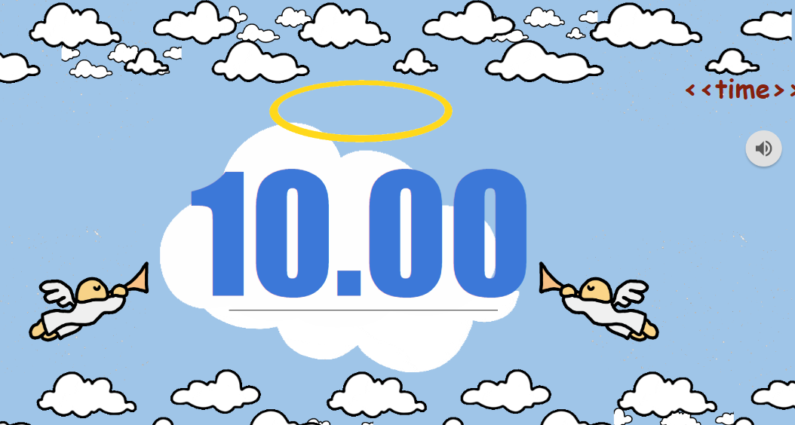  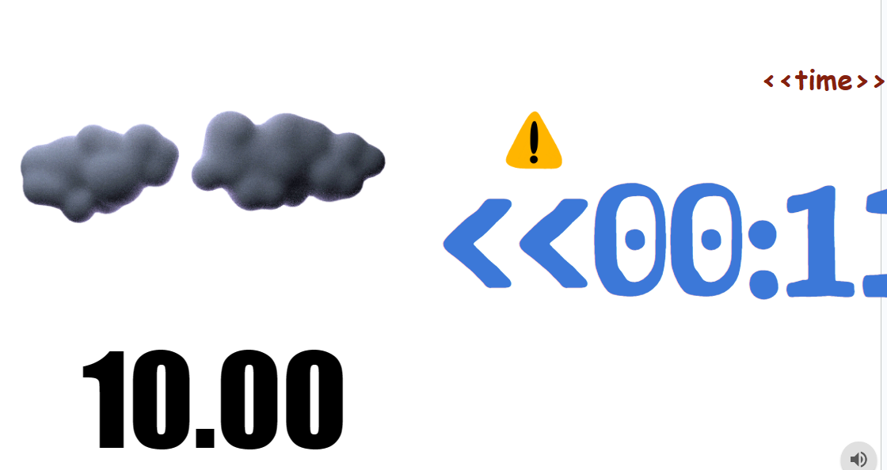
Anticipated problems (eg. lateness, classroom management) |  | Solutions
- power cut, TV doesn’t work;  - Students are late for class;  - Busy TA/Co-teacher |  | - Prepare prints out. Print out the vocabulary, switch to/adapt/create games on the board;  - Ensure Co-Teacher short catch-up chat with the student;  - Here, one can ask students that are good at English (good listening; speaking) to help them;

Language Analysis (for language lessons)
Meaning/use: [Example: using nouns to describe buildings (landmarks), or prime materials]
Form:

If Mr. Loc had a car , he would drive to work.

If + Subject + Past Simple tense + Object, [comma] Subject + [would] + base form of the verb + Object

Pronunciation: Keep an eye on ending sounds, and general language problems the students might face. Make appropriate corrections, at the right time, and grade your examples according to the target language, either vocabulary, or grammar, or a mix between these.
Potential learner problems with language | Possible solutions
- Difficulty with ending sounds.  - [idm:dif] Each ELT ESL teacher should be aware of specific cultural and language features of their English second language learners so that a counter culture-shock approach could be used. | - The students have a problem with ending sounds. It’s both culture shock and language barrier, as in their spoken mother tongue, the natives tend to just pretend they finish the word, and almost always do not pronounce the last sound within a word. Unfortunately, this is not the case with English.  This is why it’s important to correct the students, so that they practice good English, and expand their speaking skills. [i]/[p]/[t]/[g] pronunciation drilling/corrections.
[abc]:  [abc] index of terms  [idm] instructional design methodologies  [mem] mechatronics of educational management  [cm] classroom management  [ttt] teacher talking time  [tpr] total physical response  [tdr] total digital response | [T] teacher  [ST] senior teacher  [TA] teacher assistant  [S] student  [Co] co-teacher  [P] pairs  [G] groups  [TM] teams  [C] class | [I] individual
 |  | [idm]: We argue the idea that teachers should not make use of this [i] strategy, as focus has to be put on building on a communicative approach. Exceptions could be times when testing, or pronunciation drilling corrections. Even for the worksheet we use within the lessons, [ex.: writing tasks, production activities] teachers are encouraged to always have a communicative approach, pairing or grouping the students in an appropriate, well-thought and professional way.
FRAMEWORKS & ADAPTATIONS: | CELTA  CEFR | [COMPANY]  lesson plan framework

Secondary Grade 9 Week 33 Grammar: Second Conditional. Thursday, April 27th 2023
LESSON PLAN

LESSON PLAN

Time | Interaction | Stage name and aim (why?) | Procedure  (what you and/or your students and/or TA will do) | [IDM] | Observer comments
[A1]  02 mins  [B2]  01-04 minutes | [A2]  S-T  T-S  TA - S  [B2]  T-TA  T-G/TM  T-C  C-T | 0. [CM]  Classroom Slide &  Classroom Rules  Get the class (and me) ready to learn and teach;  Wait for latecomers to arrive;  Ensure Signposting. | Students clean/prepare their desks. Teacher/TA/Co-Teacher writes Signposting on the board. Gets familiar with the lesson plan and is being proactive.  Co-Teachers answer different questions students might have, and/or cannot/don’t want to express in English. | Ensure Signposting is done, before starting the lesson.  Ensure communicative environment between your team: S-Co; S-TA; T-TA; T-Co; C-T; C-TA;  Ensure a fun, communicative and safe place for the students. Ensure well-being. [idm:dif]  Play slide 1: [slideshow: presenter view]. | Obs.
05 to 07 minutes | [p]  Pairs  T-S  S-T  T-P  P-T | - REVIEW  Vocabulary  Get the students interested in the topic.  Let them speak about the topic and use some of the language that will come up in the lesson. | [idm: A1]  Students listen to instructions.  The teacher does CCQs/ICQs.  Students raise their hands to answer questions.  Teachers help the students to improve their speaking, by making appropriate and differentiated corrections, at the right time.  Teachers could also take notes with possible identified issues in speaking skills, in order to solve them afterwards. | Ensure CCQs & ICQs are finished before going on with the activity.  Example:  Do you talk? [no]  Do you talk to your partner? [yes]  Do you look? [yes]  How much time do you have to answer the question? [1 minute]  Do you say words or sentences? [sentences]  Use digital TPR [TDR] to ensure a fun time for the students.  Example: gifs instead of pictures. [make sure not to overload the slide with different distractors].
05 to 07 minutes | [p] Pair  T-P  T-G  P-T  G-T  TA-S  TA-P  P-TA  S-TA | 2. SET IN CONTEXT  Driving Questions slides: nr. 26, 27, 28.  Introduce the vocabulary in an easy to understand, fun to keep up with, and academic way. | [idm: C1]  Teachers elicit/present the slides one by one, and ask questions to the students. They encourage the students to answer [p] in pairs, or as a [g] group. Positive reinforcement on [CM] made if necessary.  Teacher Assistant [TA] ensures good communication between teacher and students, pairs or groups. They translate if needed, and keep the class engaged with teachers’ questions.  Students pay attention and answer questions first individually, and then, in pairs or groups. They repeat words, at times when the teacher asks them to do so: ex.: ending sounds.  Transcript:  What would you be if you were a gemstone?  If I were a gemstone, I would be an amethyst.  If I were a gemstone, I would be a diamond.  [TPR] audio slide | Applied Principle of Differentiation due to group of age. Use [p] and [g] in order to decrease levels of stress and individual attention onto / situations when students are struggling with language, special cases, etc:  [A1]:  [T] - [S] - [T] = [T] {incorrect}  [T] - [P] - [T] = [T] {incorrect}  [B1] In order to decrease [TTT] teacher talking time, teachers could just present a slide, and ask/mime to students to read the questions using TPRs:  [S] - [T] - [P] = [S] {partially correct}  At an expert [C1] level of delivering this lesson, from the communicative point of view, teachers would encourage pairs to ask and answer questions, without [t] being the middleman, or starting the conversation. Beside ensuring CCQ/ICQ, teachers would use TPRs/TDRs to ensure [s] students/[p] pairs conversation from the first sentence.  [S] - [S] - [P] - [P] = [G] - [T] {correct} | CEFR [idm] [A1-C2]  A1  A2  B1  B2  C1  C2  [d12: idm] Case Study  [D1-F2]  D1  D2
05 to 07 minutes | T-P  P-T  TA-P  P-TA | 3. PRE- PRESENTATION  [Guided Discovery]  Matching Game  Allow the students to discover the form of the Second Conditional, read examples, and understand its functions. | In pairs, students look at the flashcards, read the sentences and think on how to match the flashcards, in two columns. They try to create two columns: one for cubs, and the other one, for cylinders.  Teachers are being encouraged to ask for any two volunteers to go to the board and rearrange the flashcards, in two columns. If first [p] is struggling, next [p] comes to the board.  [CM]  If the class behaved well, use CM TPR to praise them.[Example: slide with a 10.00 mark and angelic choir sound effect; see lesson folder-CM]; or {clapping sound effect};  Transcript:  TITLE - The Second Conditional  FORM - IF + S + V2 , S + would + V  TENSES: past simple [V2], and base form of the verb  USED - to give advice & for imaginary situations | CCQs and ICQs before teaching this activity.  Main aim: to ensure presentation success’ and understanding, in a fun and entertaining way [ex.: guided discovery approach].
02 to 05 minutes | [A2]  T-S  S-T  T-TM  [B2]  T-P  P-P  P-T | 4. PRESENTATION  Slides 39-42.  Give the students feedback on their discovery and sentences. | [idm: B1]  Students listen to the teacher explaining the Second Conditional. They talk if asked to, and pay attention.  The Teacher Assistant ensures good class’ behavior and addresses individual questions, if needed.  Teacher conducts the presentation and does [CM] positive reinforcement, if necessary. | [TTT] could be decreased if teachers let the students read the sentences within the presentation.  There is also the option of pair/group/class drilling.  [t] - [tm] - [t] - [p] - [s]  A positive reinforcement on [CM] means teachers scroll up or down the CM slides, showing the students different gifs according to how they behave. The teacher will try as much as possible to keep the Mark 10.00 on the board, even at hard times when class gets noisy, or possible unexpected things happen.
07 to 10 minutes | S-P  P-P  P-G  G-TM | 5. Practice  Look and say  From Slide nr. 45 | Teachers present the slides and elicit good answers. They encourage students in groups of four to speak out correct sentences from prompts.  Teacher Assistants help the groups if necessary.  Students answer in groups of four, they look at the prompts, speak and take turns to guess the correct Second Conditional sentence. | Do CCQs/ICQs;  Put the students in groups of 3, 4, or 5. Ask [g] to choose one student to speak out the sentence.  Differentiation applied here, in order to save as much time as possible, and tick as many boxes within the Grammar Lesson Framework/ Procedure/ Stage/ Practice examples.
05 to 07 minutes |  | 5. Production  Pictures to words  Grammar Worksheet  Freer activity  (Homework) | Students team up in groups of four. They look at the pictures and write sentences using the second conditional, as in the given example. Students write sentences according to the pictures depicted.  TAs ensure good CM and help groups, if needed.  Teachers eye-skimm the class/groups and offer support with writing sentences, if necessary. Any special case, of any sort, would be addressed by either the T or TA.
02 to 05 minutes | CM reward moment  T-TM  TM-T  T-S  S-T  P-T  T-P | 6. Spinning Wheel & Winning team  Classroom Management Reward Moment  [Company] Promo video | If the 10.00 mark is still on the board by the end of the lesson, teachers spin the wheel. One student to get a treat/gift;  Co-Teachers/TA help the teacher to share stickers for the winning team.  CM 10.00 mark slide with the angel choir is shown on the screen.  If there is enough time, present the [COMPANY] promo video [1.5 minutes].  Obs.: Teachers could adapt the video according to class mood/level/age/skills, etc. | Prepare beforehand the spinning wheel for public school usage. This means, on the spinning wheel there should be numbers from 1 to 50, or as many students are in the class. Here is a great website with awesome options for you to personalize your wheel:  Secondary (wheelofnames.com)

Lesson planning guidance:
- Decide if you are doing a language (grammar/lexis (vocabulary) or skills lesson)
- Have a clear main aim. Write this in terms of what the students will have done by the end of the observed lesson. Be specific and refer to the context.
- Think about problems that may arise and identify solutions
- For language lessons - identify the key language students will be learning and complete the MFP analysis
- For skills lesson - specify the skills they will practice and identify any problems and solutions
- For each stage, be specific about what you and/or students will do. Write this so that another person can understand and follow.
- Think about why you are doing each stage and write the stage aim. If you have stages that don’t fit with your main aim, consider whether you need to have this stage at all.
- Ensure the students have some opportunity to use the language during a one hour observed lesson - we want to see students speaking
- Consider having some flexi-stages that could be omitted if you are running out of time, without affecting the achievement of the lesson aim
- Don’t spend too long on a warmer (10 minutes maximum)
- Check your timing is realistic (remember to allow for instruction-giving and feedback)
- Check there is variety in the interaction patterns so students are not sat in the same place the whole lesson
- There is no need to include a lesson plan for the part of the lesson that is not being observed.
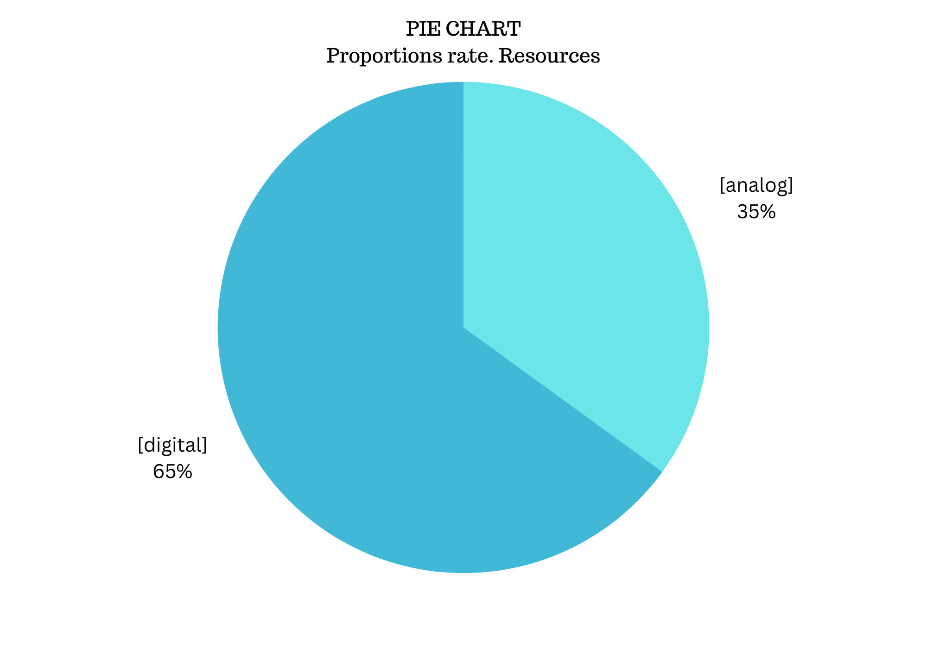
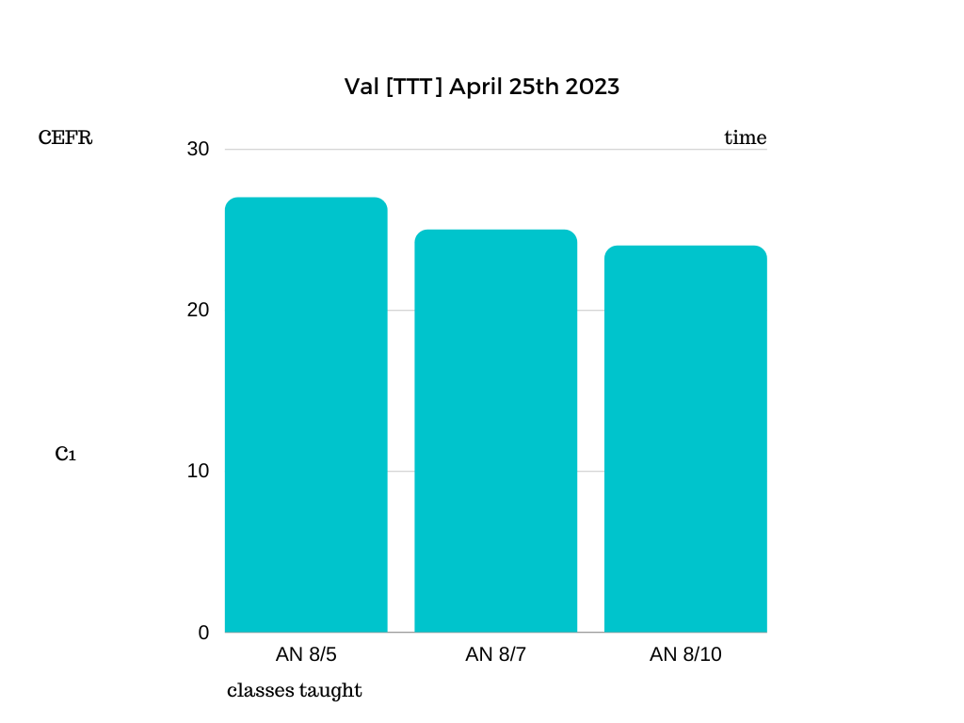

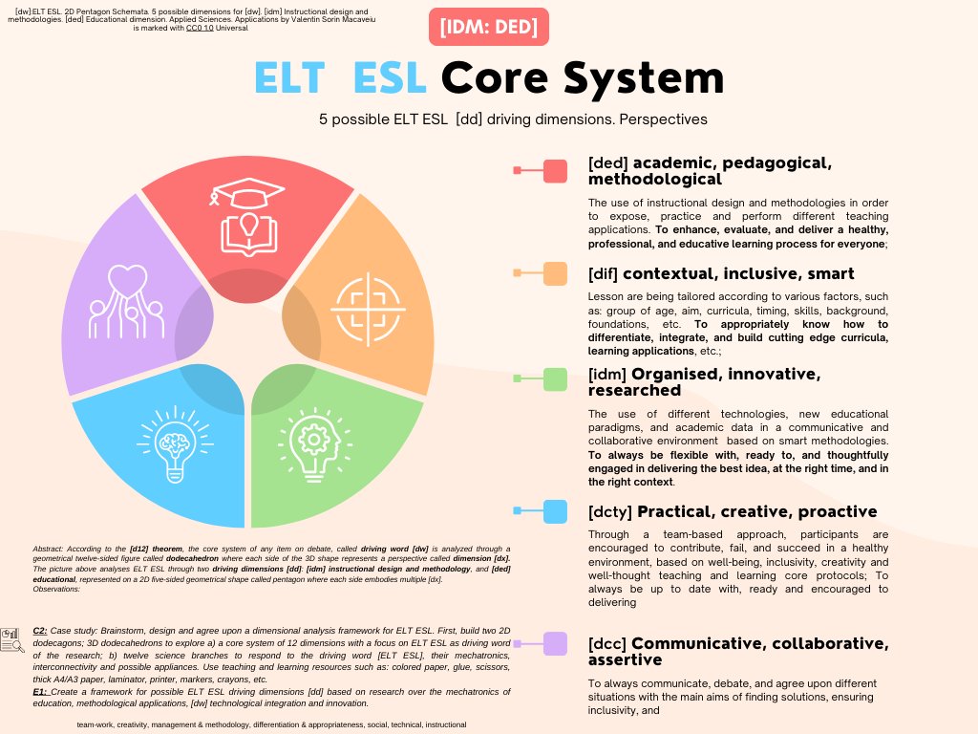
[dw]:ELT ESL. 2D Pentagon Schemata. 5 possible dimensions for [dw]. [idm] Instructional design and methodologies. [ded] Educational dimension. Applied Sciences. Applications by Valentin Sorin Macaveiu
is marked with CC0 1.0 Universal

